**ELC - Aqua Global Bypass scope**

**CHG1071504 implementation KB document**

**Submitted to**

**By**

**Wipro Technologies**

**Revision History**

|  |  |  |  |  |
| --- | --- | --- | --- | --- |
| **Version** | **Date of Revision** | **Description of Change** | **Reason for Change** | **Reviewed By** |
| 1.1 | 19-June-24 | Initial Draft | NA | Mihirkumar |
|  |  |  |  |  |
|  |  |  |  |  |

**Author/Reviewer/Approvals**

|  |  |  |  |
| --- | --- | --- | --- |
| **Name** | **Designation** | **Responsibility** | **Date** |
| Mihirkumar Jani | Consultant | Author | 19-June-24 |
| Kannan Kuppusamy | Technical Lead | Reviewer | 20-June-24 |
| Felix Jebamani | Lead Consultant | Reviewer | 20-June-24 |
| Jamshid Abedi | Executive Director | Approver | 12-July-24 |

**Table of Contents**

Objective of the Document 3

1.0 Purpose and Scope 3

2.0 Aqua Global Bypass scope 4

3.0 Runtime Policy with Block Non-compliant Images control 5

4.0 Testing of the ‘Aqua Global Bypass scope’ 5

4.1 Scenario 1: 6

4.2 Scenario 2: 7

# Objective of the Document

This document is regarding Aqua Global Bypass scope.

# 1.0 Purpose and Scope

Aqua will not detect or enforce any violations of Container Runtime Policies, Firewall Policies, or Kubernetes Assurance Policies by containers within this bypass scope.

This Global Bypass scope applies to Estee Lauder Companies Inc. (the “Company”) whole Azure AKS clusters environment.

# 2.0 Aqua Global Bypass scope

Below steps needs to perform to reconfigure Aqua Global Bypass scope.

Below file is for ‘Aqua Global Bypass scope’ configuration, need to update the configuration in Step 3



Figure 4: Aqua Global Bypass scope (Navigating to create policy)

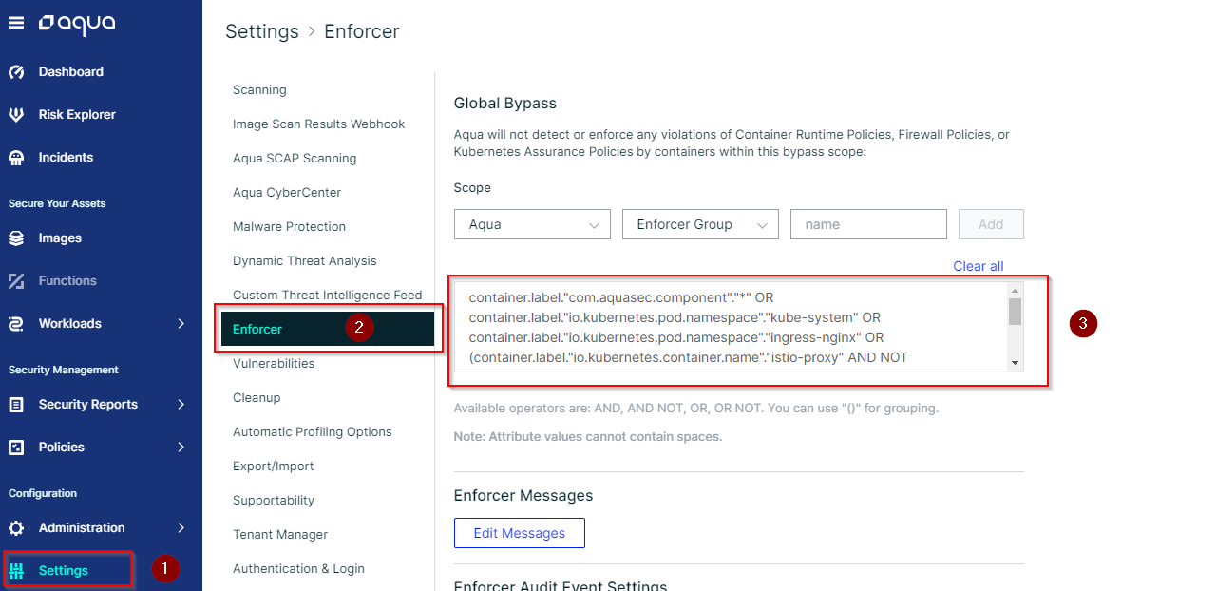

# 3.0 Runtime Policy with Block Non-compliant Images control

We are testing the ‘Aqua Global Bypass scope’ with Block Non-compliant Images control with Enforce mode.

**Controls:**

Block Non-compliant Images: Prevents the container from running non-compliant images

Figure 4: Runtime policy (Navigating to create policy)

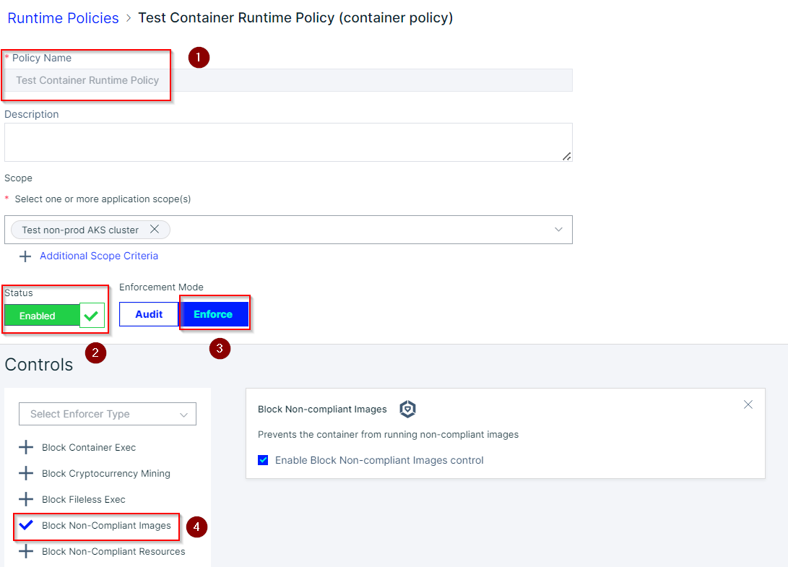

# 4.0 Testing of the ‘Aqua Global Bypass scope’

We are testing the ‘Aqua Global Bypass scope’ on ‘AKS-AM-EastUS-NP-SREDO’ AKS cluster.

Below non-compliant Image tried to deploy for testing.

Image: aquasec/kube-bench:v0.7.0

Below Deployment files need to deploy in AKS cluster for the testing.

 

## 4.1 Scenario 1:

Unable to deploy non-compliant Image in namespace ‘app-two’, because it is not part of ‘Aqua Global Bypass scope’ configuration.

Namespace: app-two

Figure 6: Audit event log

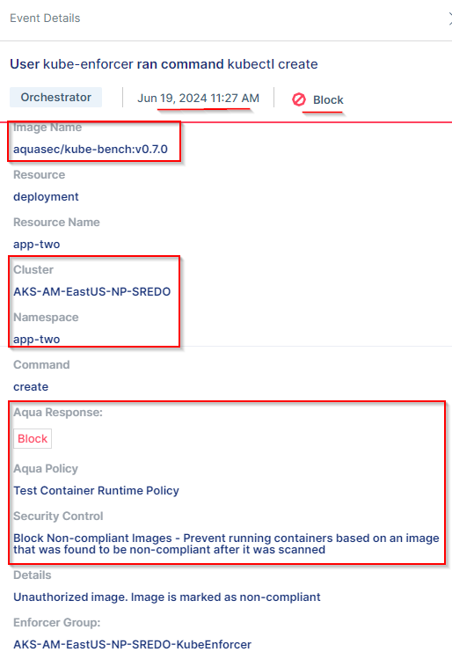

The Event alert give us details along with AKS cluster name, Namespace, Aqua policy name, Security Controls and Finding with violated parameters.

Below files for the event log:



## 4.2 Scenario 2:

Able to deploy non-compliant Image in namespace ‘aqua-security’ because the namespace is part of Aqua Global Bypass scope configuration.

Namespace: aqua-security

Figure 6: Audit event log

The Event alert give us details along with Image name, AKS cluster name, Namespace and Aqua Response.

Below files for the event log:

